Part 2: Static Acquisition (3 marks)
Course Name: FRS301-Digital Forensics
Student Name: Nguyễn Trần Vinh – SE160258
Instructor Name: Lê Tiến Dũng
Lab Due Date: 28/2/2023

What You Need for This Project
- VMware Workstation
- Any other tools you choose to use
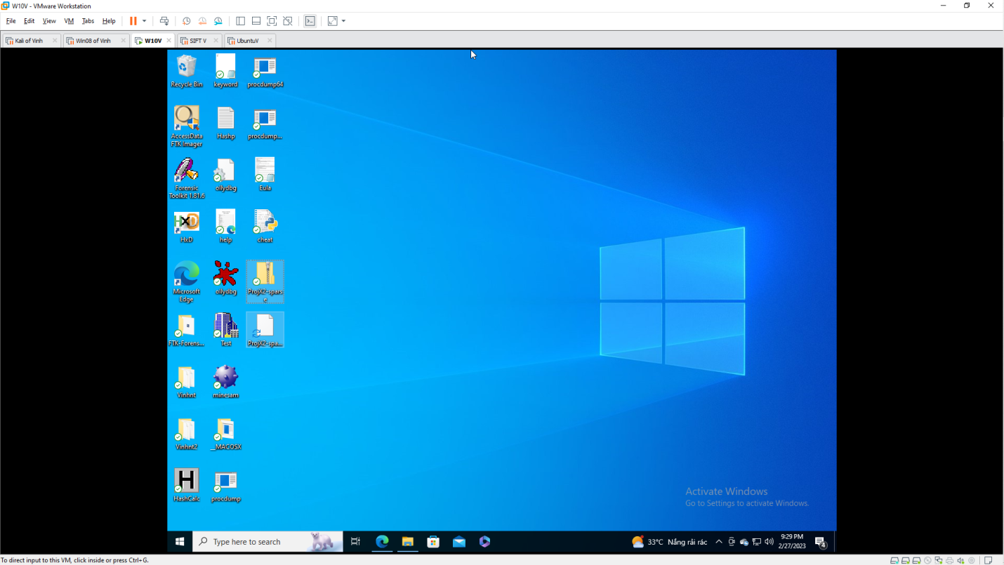

Getting the Evidence File
- Download ProjX2-sparse.zip file
- Calculate the MD5 hash of the file and verify that it matches the value shown to the right on this page.
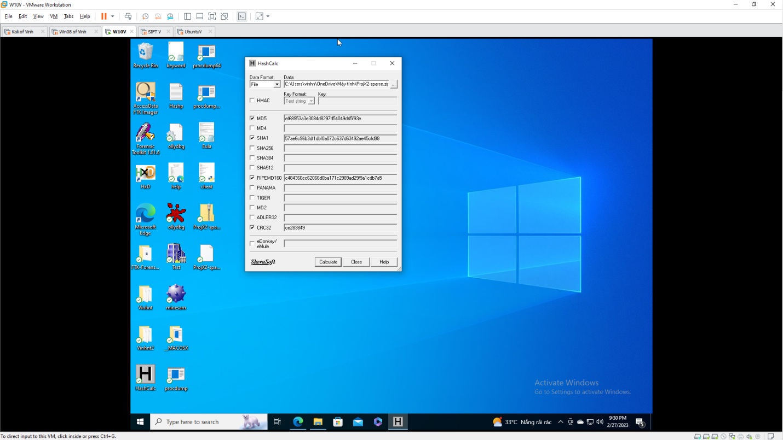
- Unzip the file to extract the virtual hard disk inside.

Imaging the Evidence Drive
- Mount the evidence drive in an appropriate virtual machine.
- Use any technique you like to make a correct forensic image of the drive.
- Calculate the MD5 hash of your forensic image.
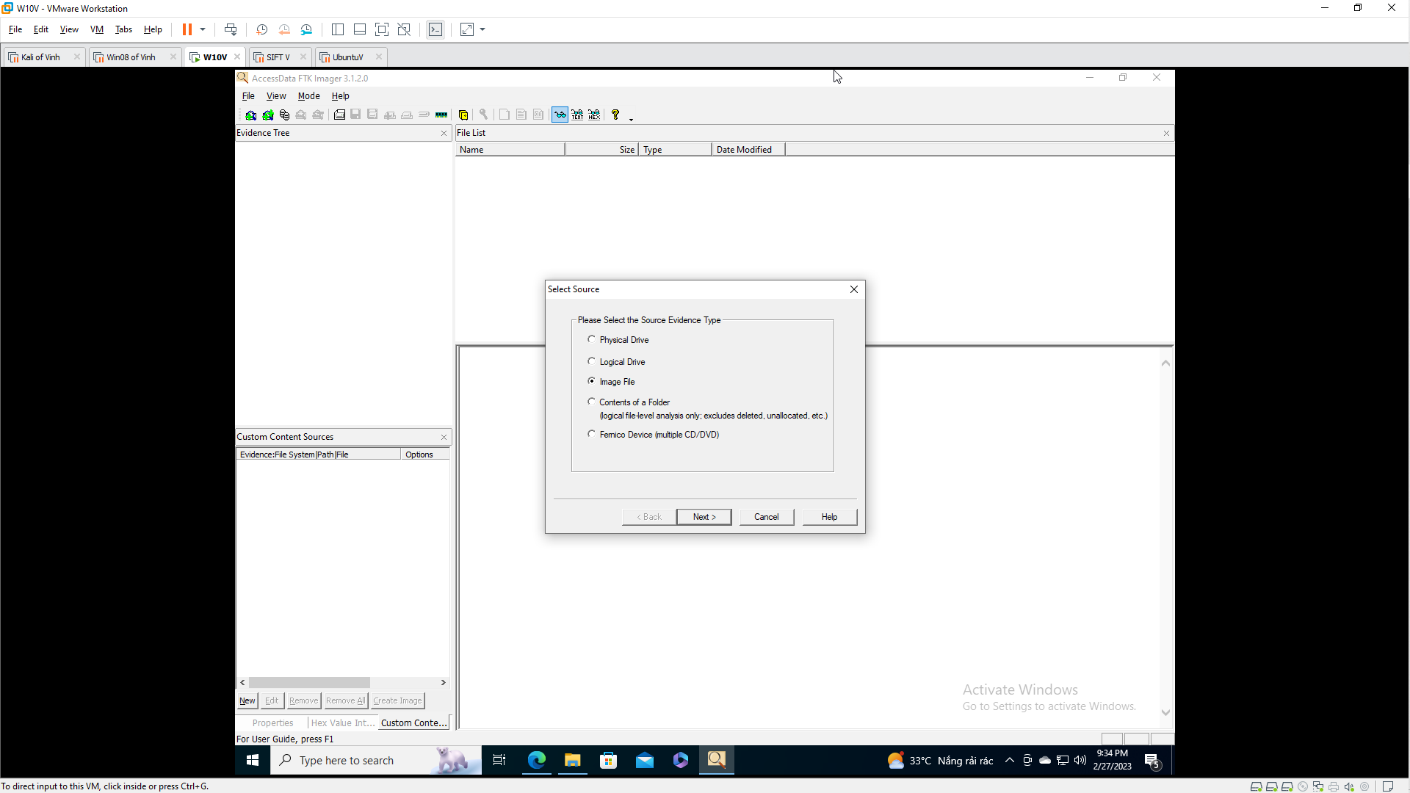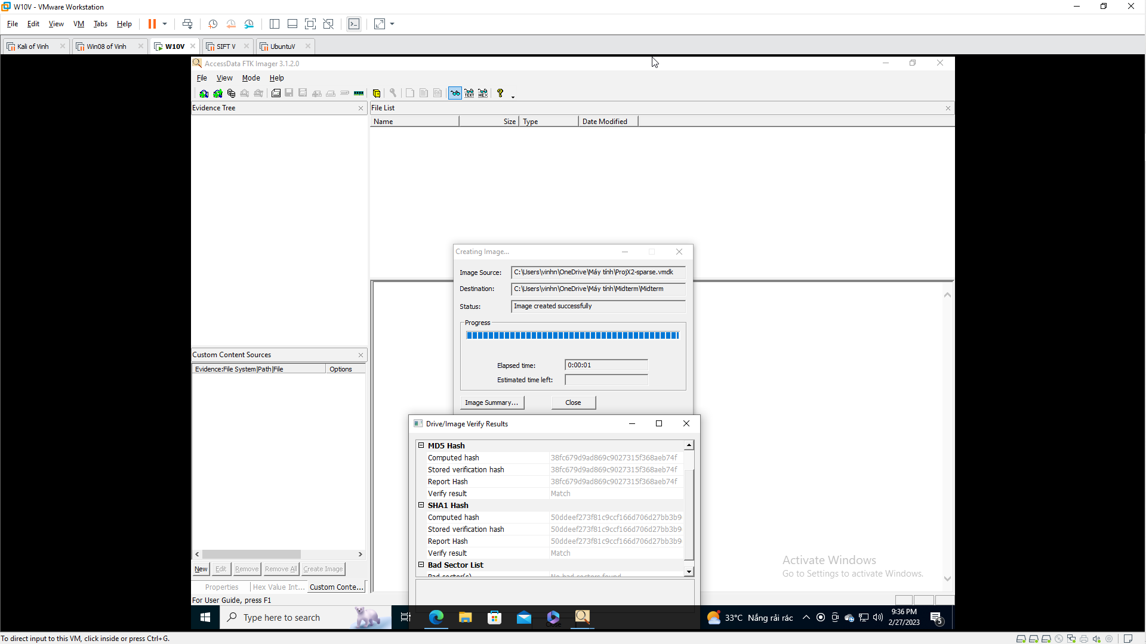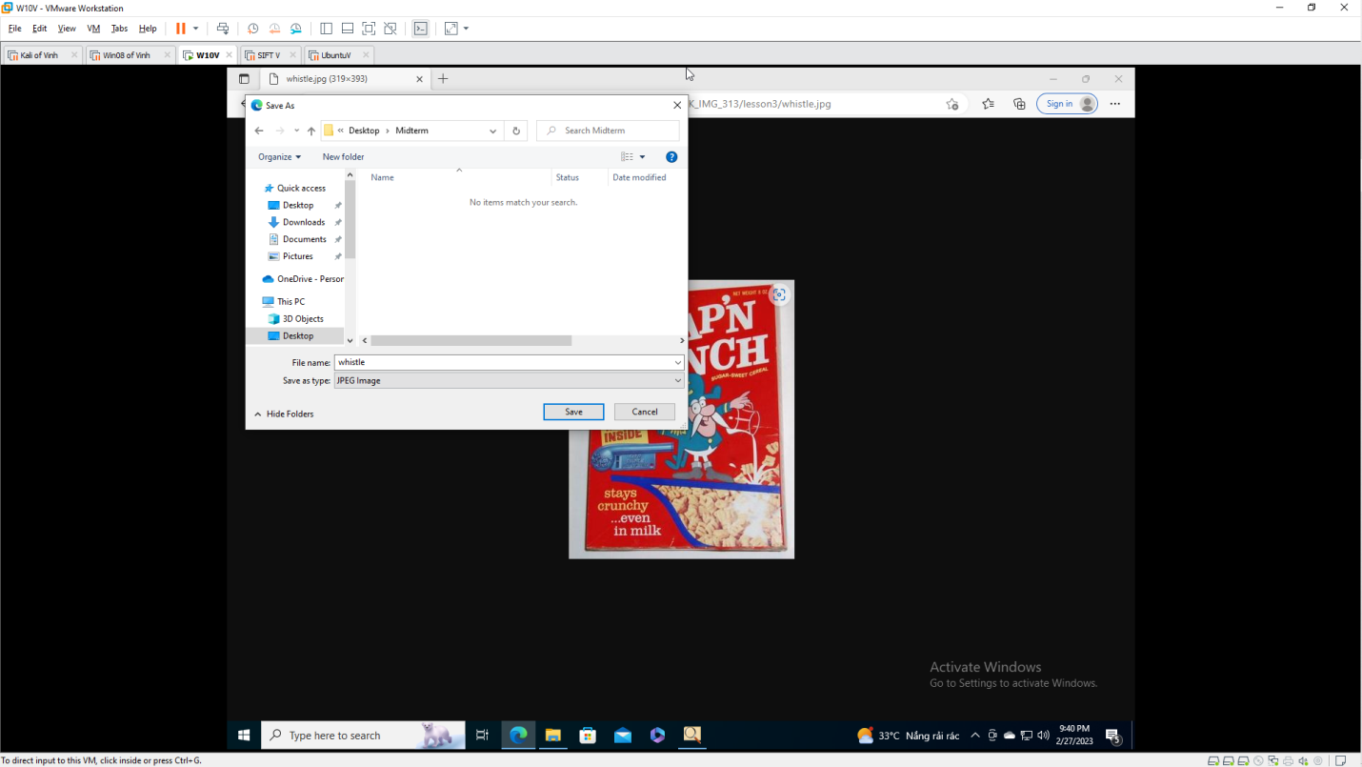
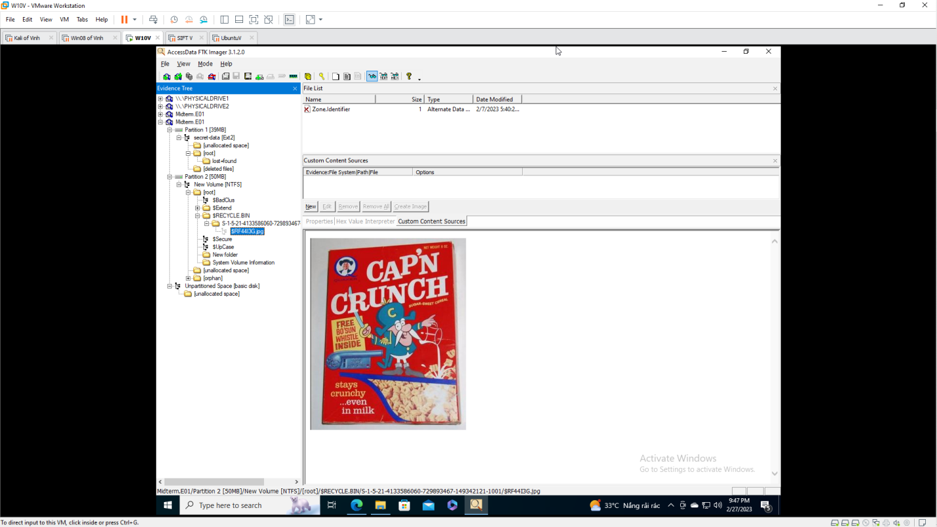
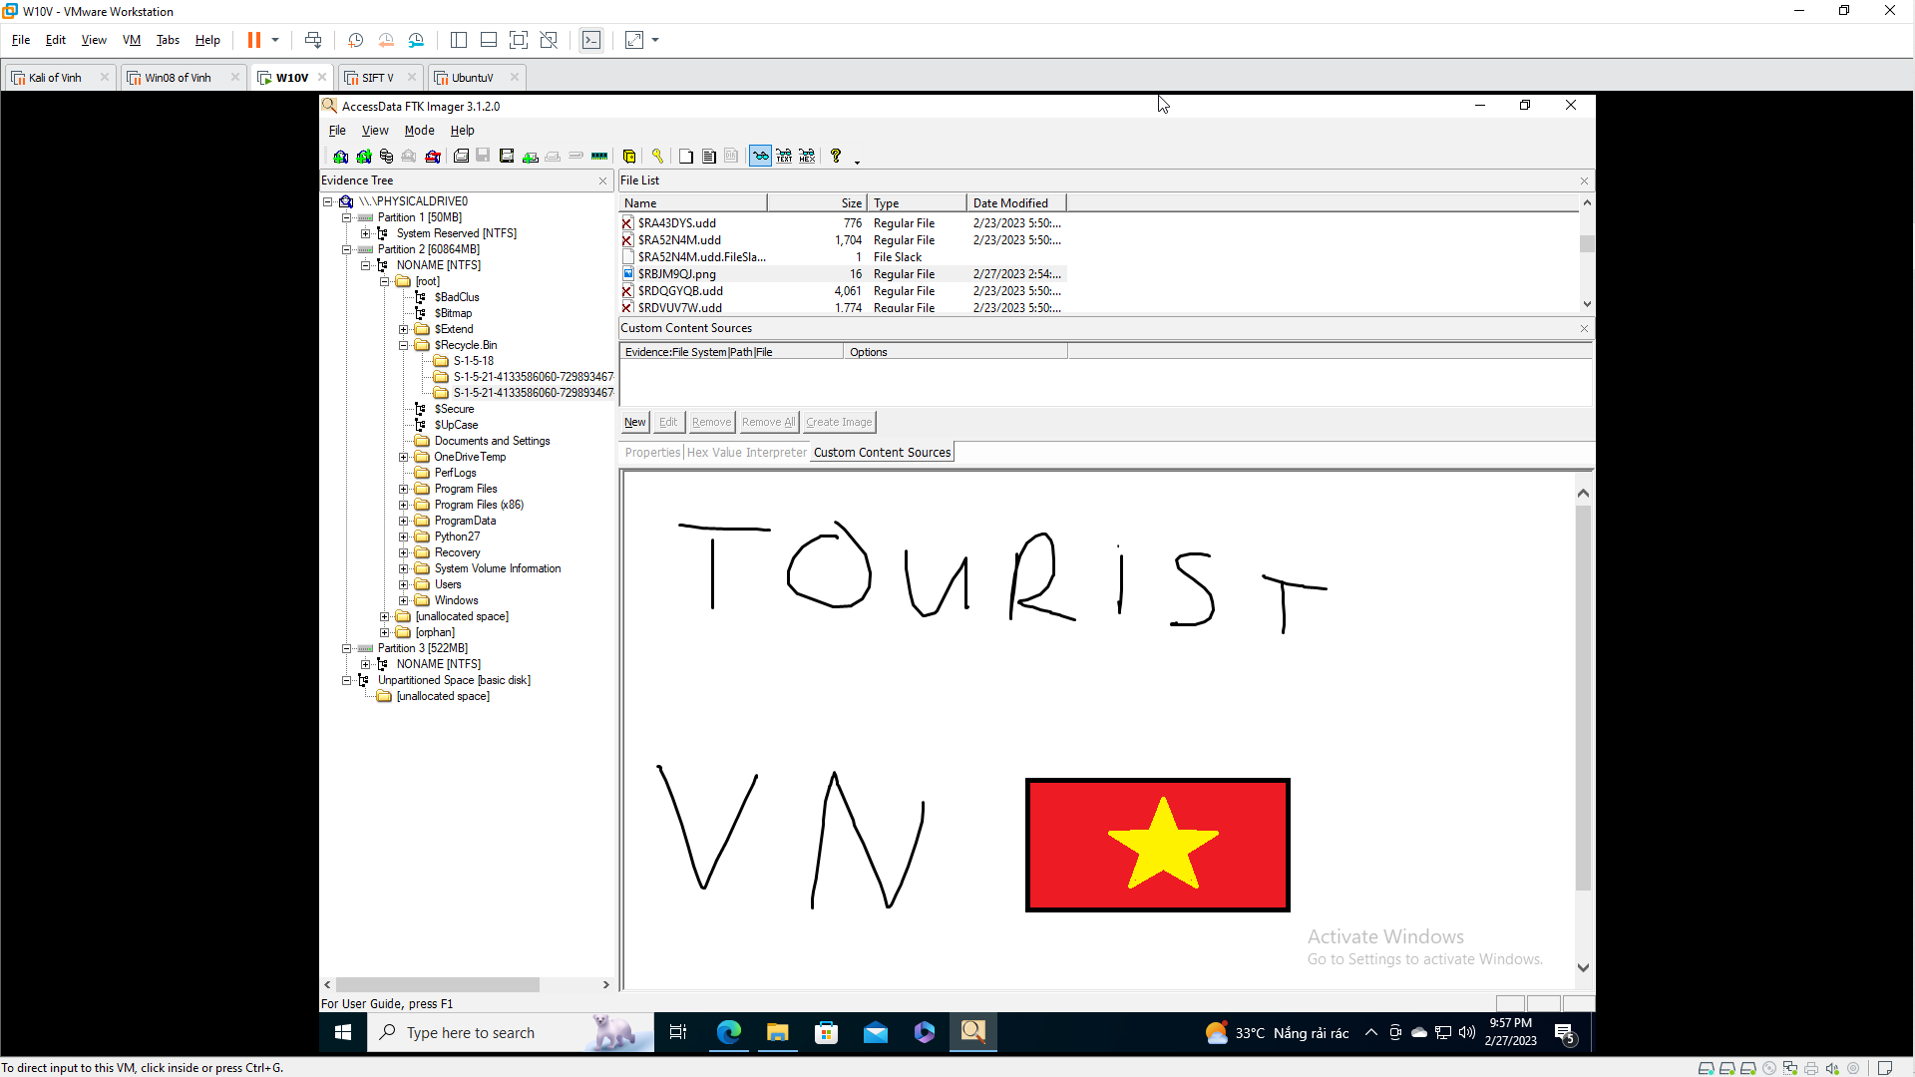
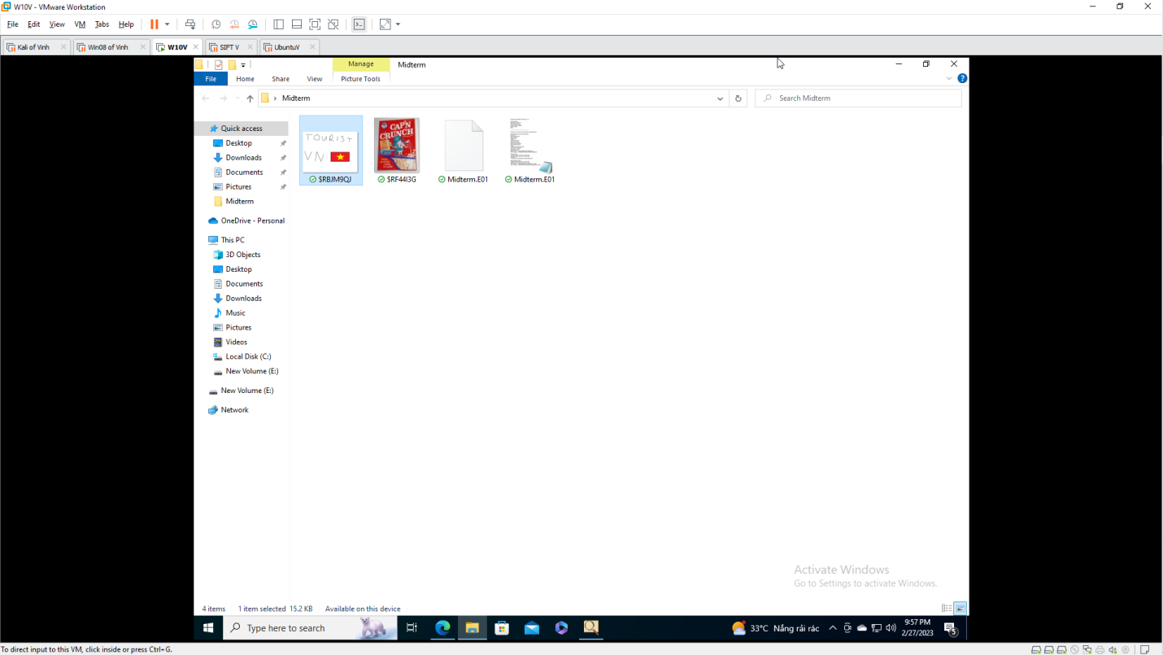

Saving a Screen Image
Make sure your screen shows the MD5 of the image, from whatever tool you chose to use.

